**Function:**

Any relationship that assigns to each element of on set one and only one element from a second set

Domain:

The first set

Co-domain:

The second set

Range:

Elements of the co-domain that the elements of the first set map onto

e.g.

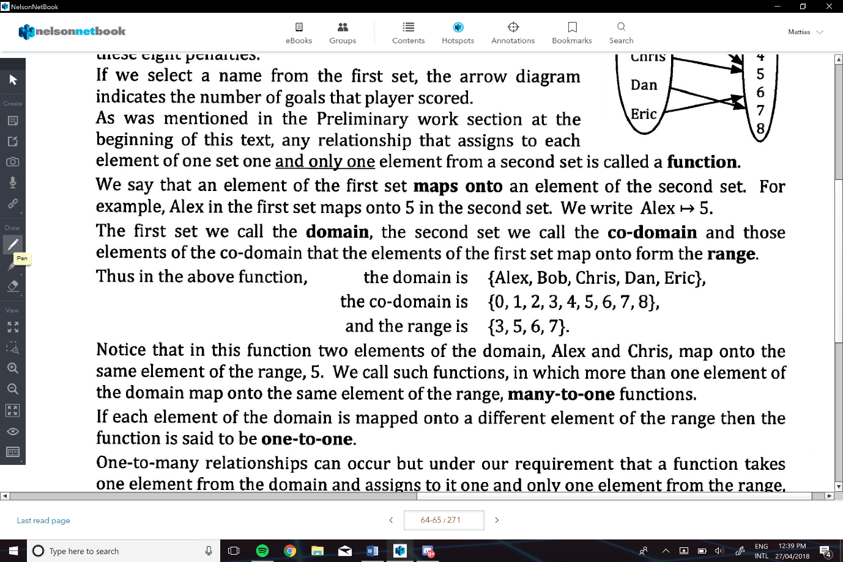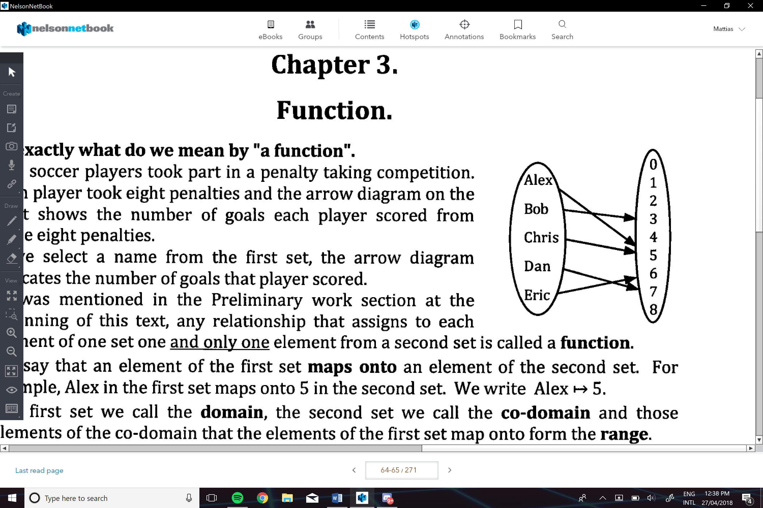

Many to One Function:

More than one element of the domain map onto the same element of the range

One to One:

When each element of the domain is mapped onto a different element of the range

** one to many is not a function**

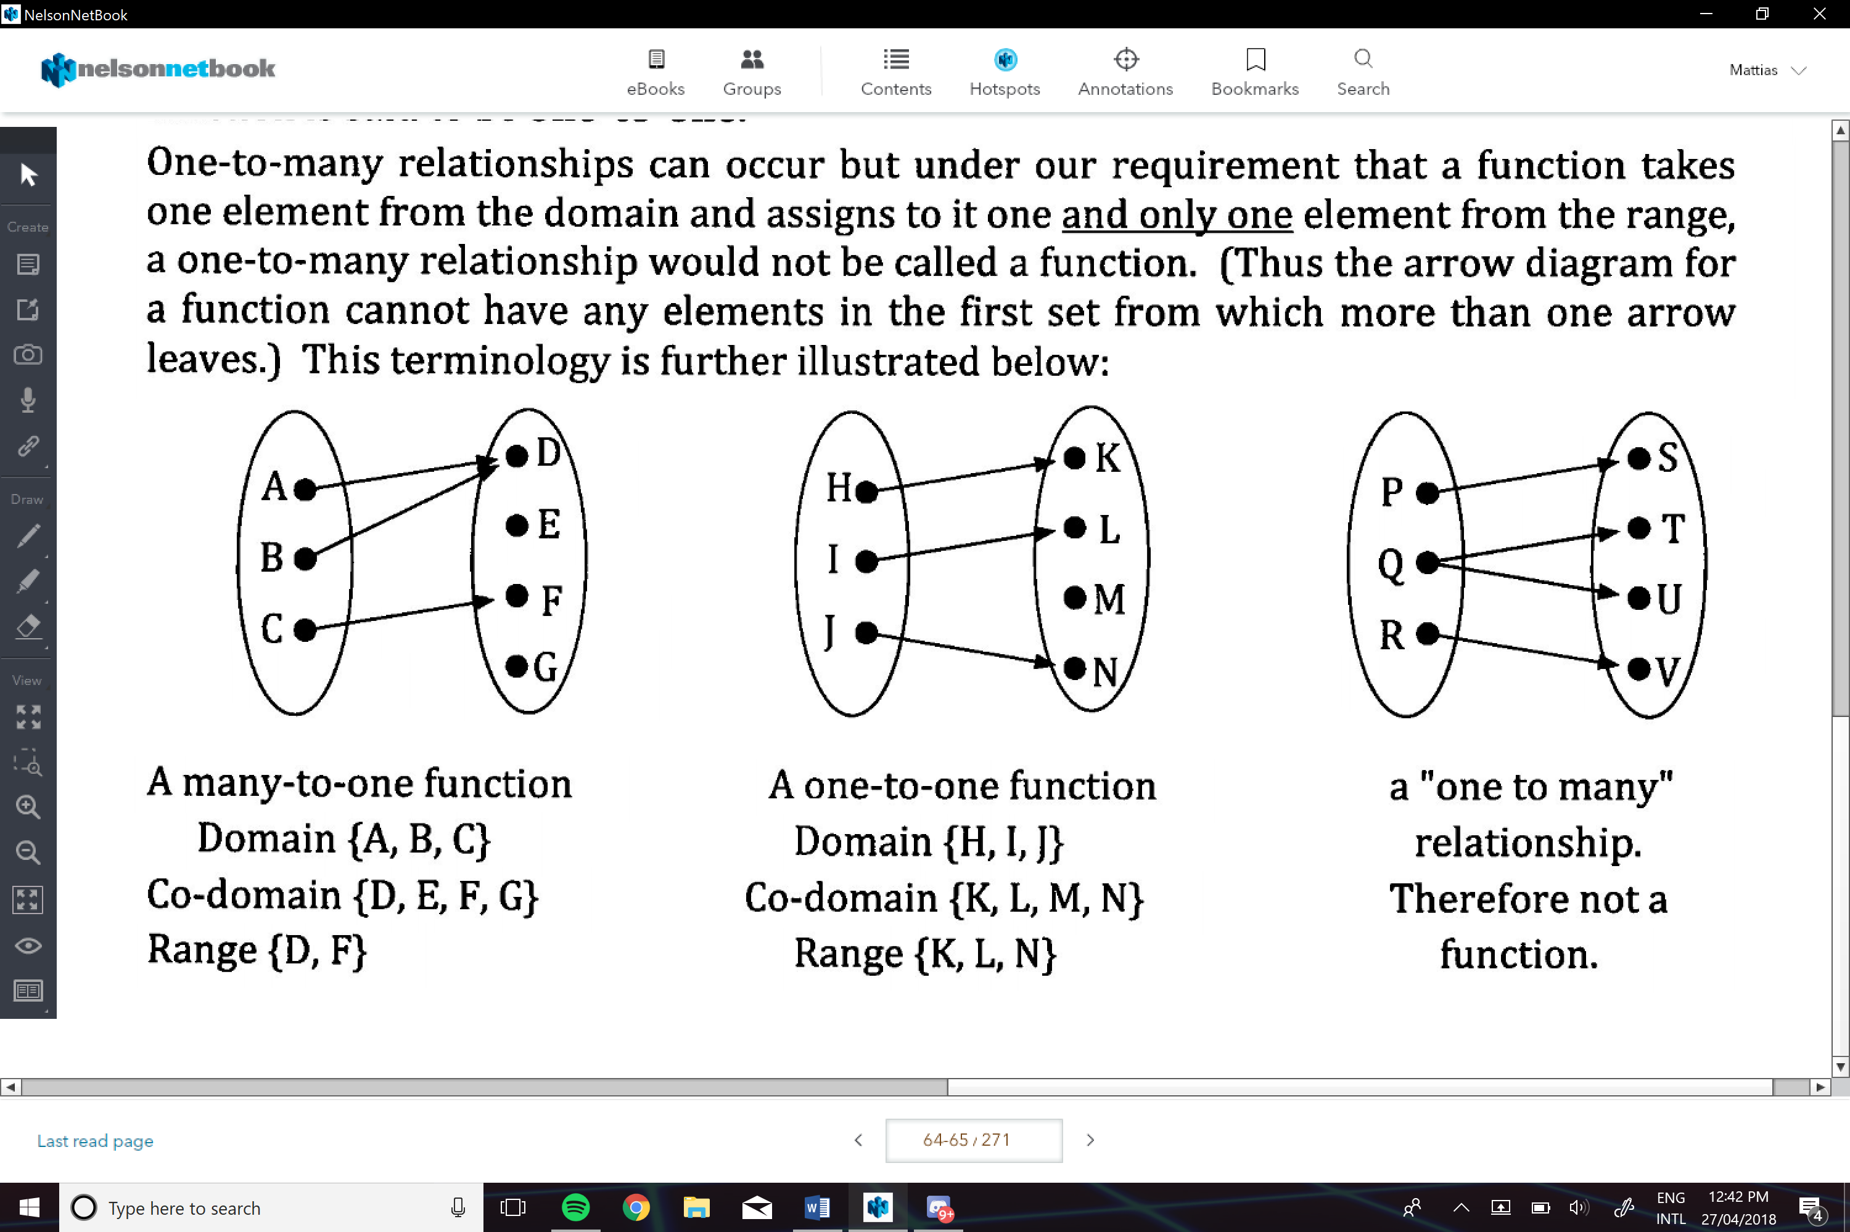

e.g.:

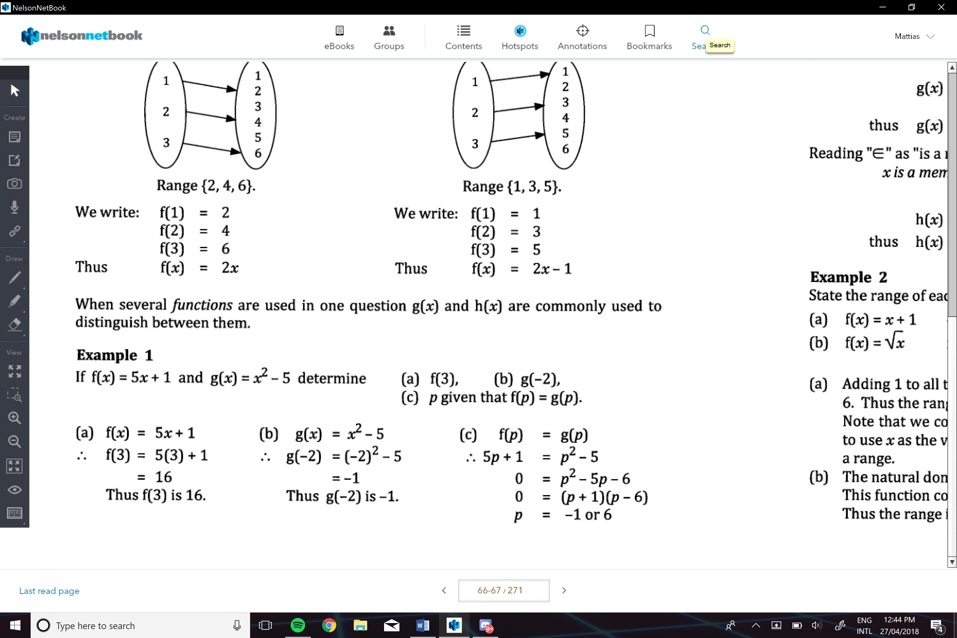

Natural Domain:

All the numbers which the function “can cope with”

* This is if we aren’t given a specific domain

e.g.

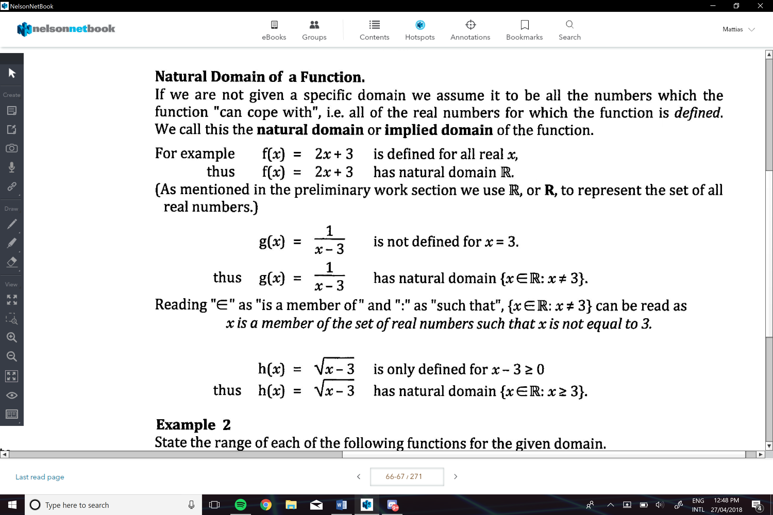

e.g.

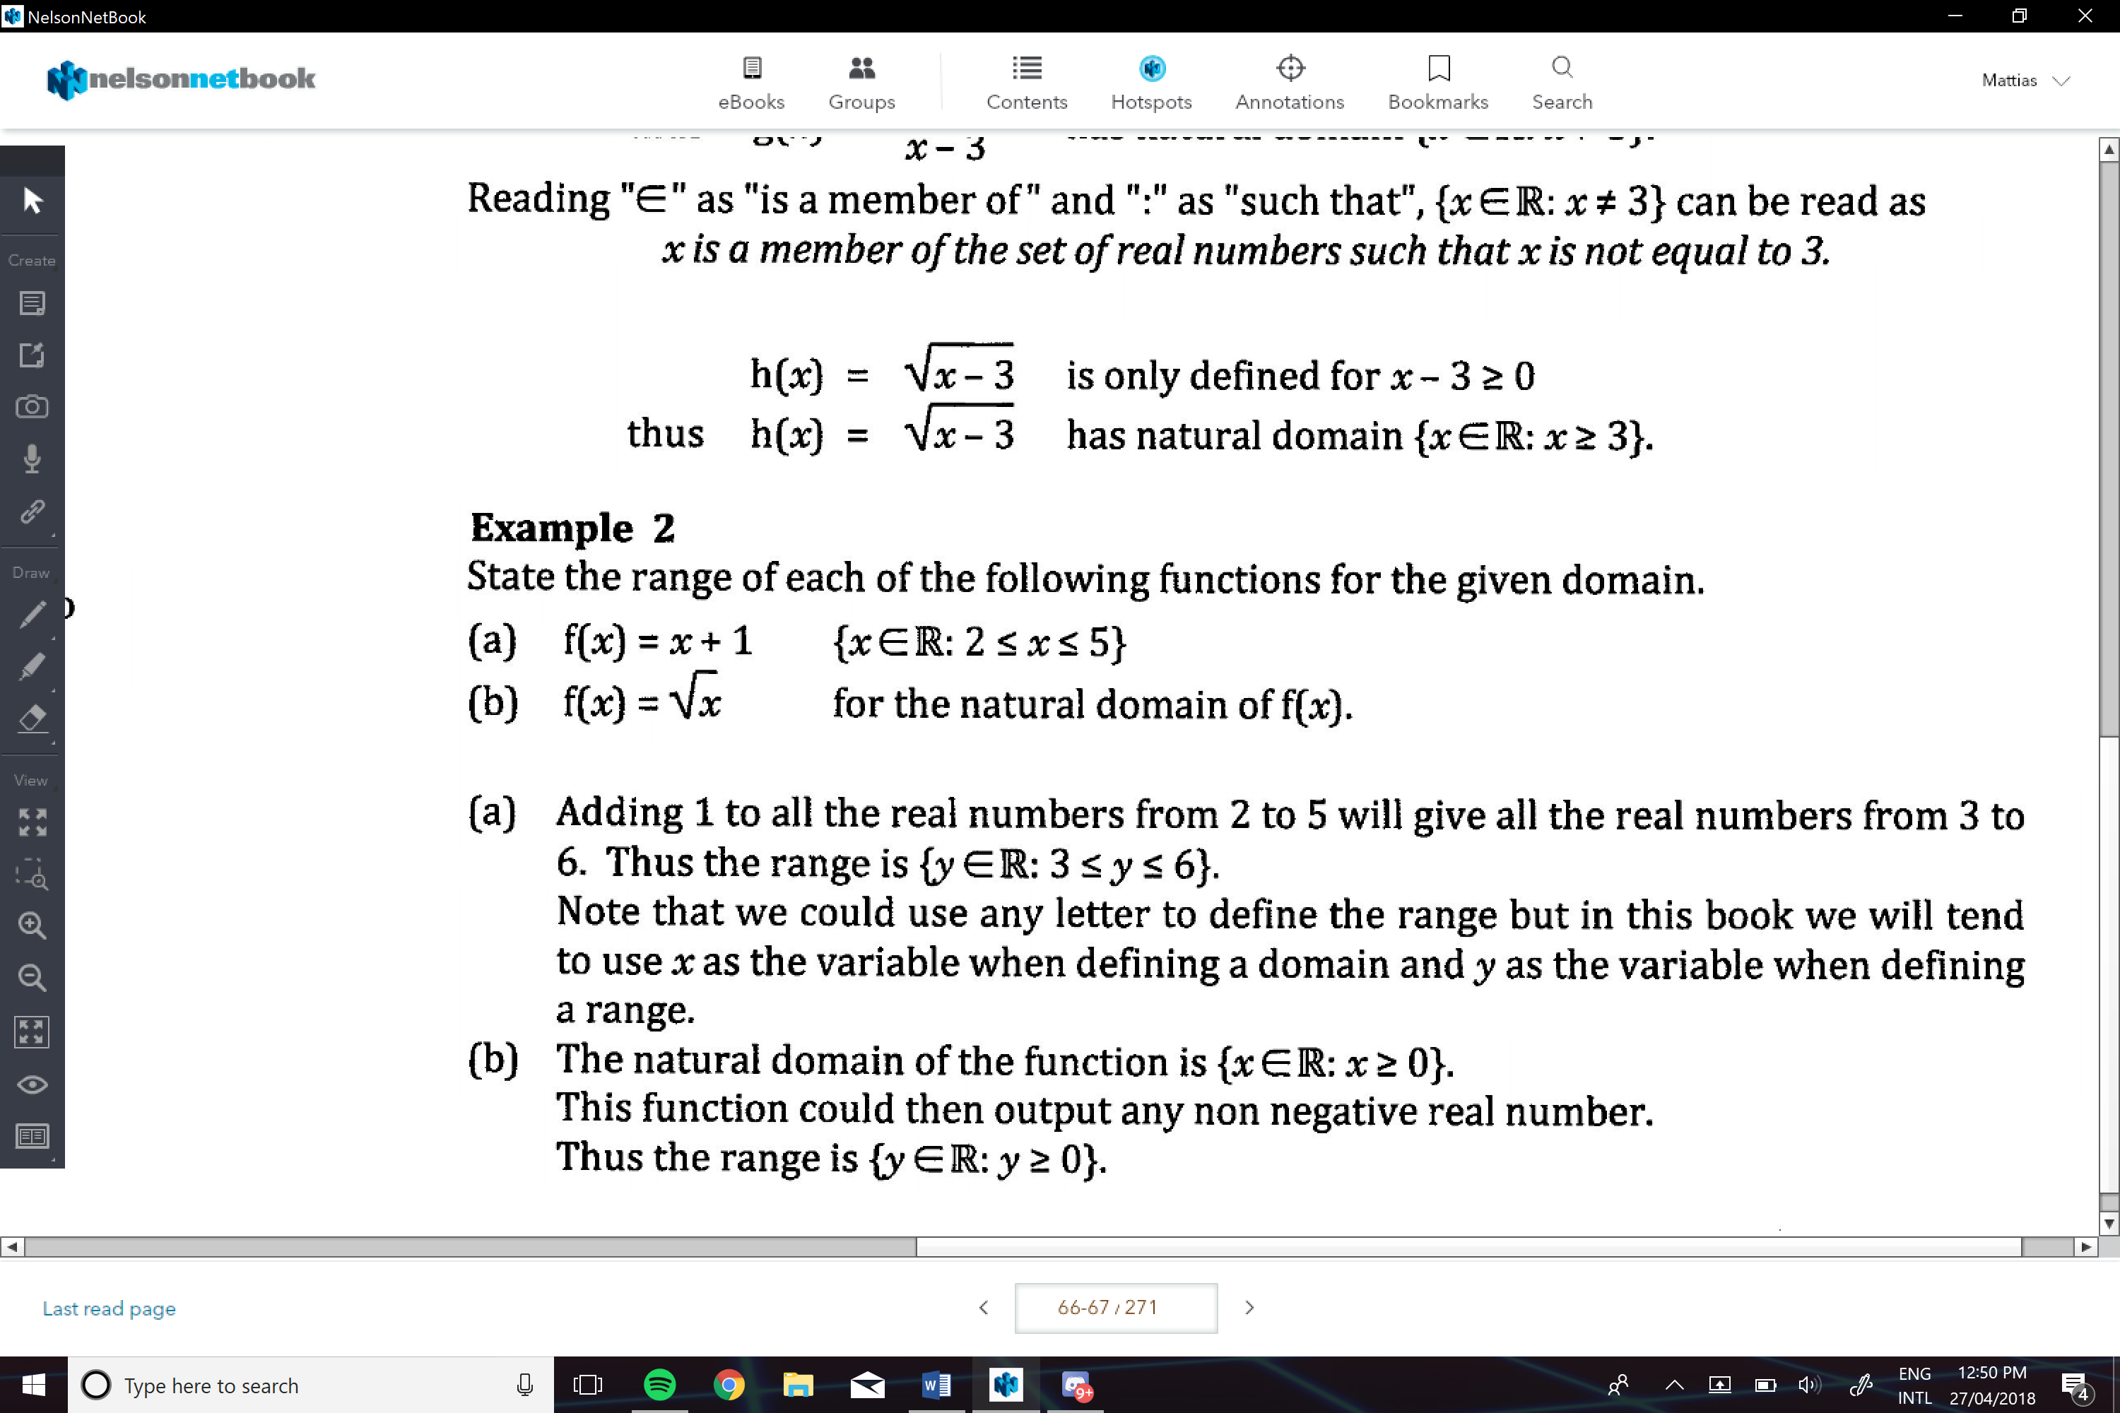

**When graphing**

The Line should not cross the y-axis more than once, it can however cross the x axis as many times